**Age Scotland & Scottish Government Fund**

**Encouraging and Supporting Grassroots Activity**

**Guidance and Application Form**

Funding for groups delivering community-based support for people living with dementia and unpaid carers.

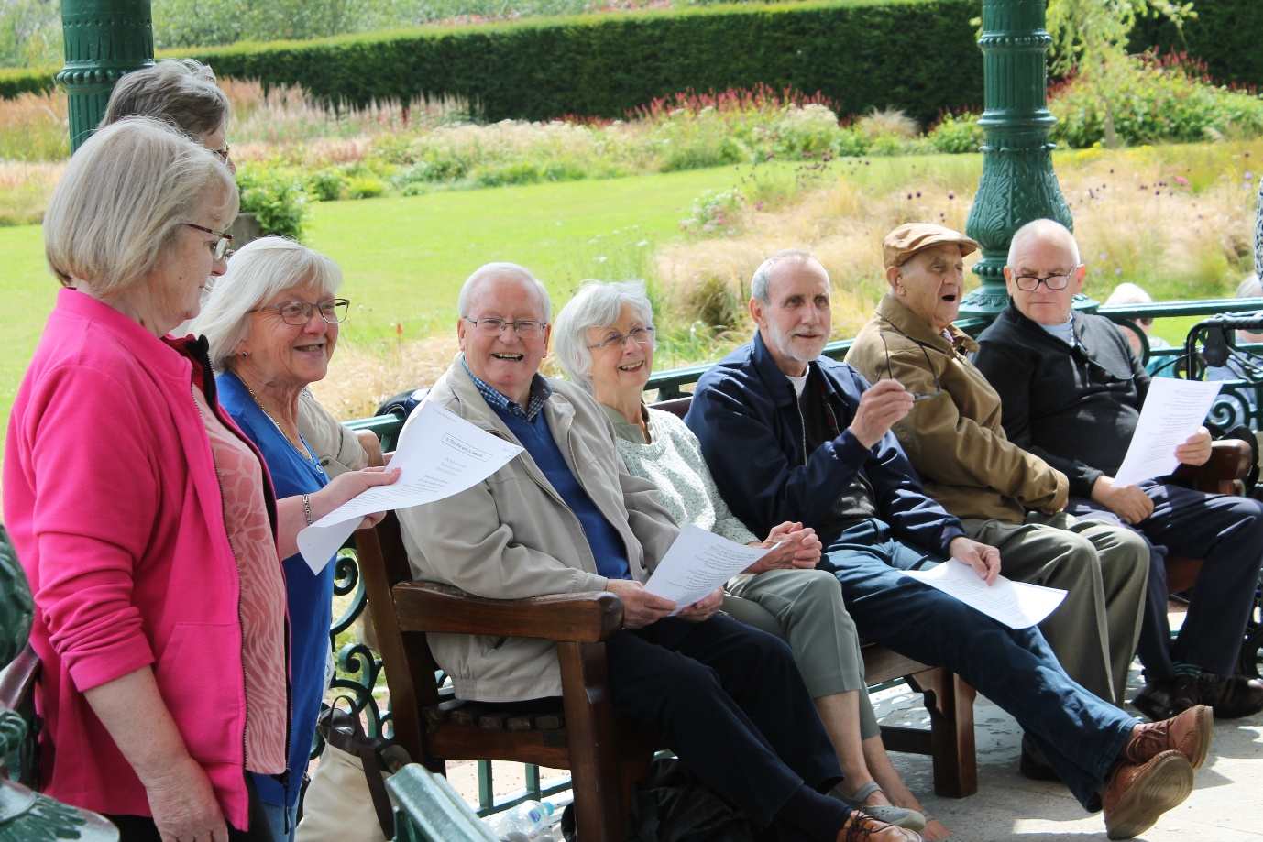

Apply for grants between **£5,000 and £20,000**

Deadline for applications**: 5pm on Friday 5th September 2025**

Email address for submitting applications**:** [**DementiaGrants@agescotland.org.uk**](mailto:DementiaGrants@agescotland.org.uk)

|  |
| --- |
| **Before completing the application form, please read the fund guidance in this document (pages 2-6). This outlines the eligibility requirements of this fund and what you will need to demonstrate in your application.**  **Click here to skip to** **Applica****tion form** |

## **What is this fund?**

Our Encouraging and Supporting Grassroots Activity (ESGA) fund is being delivered by Age Scotland’s Dementia team with funding from the Scottish Government.

The aim of this fund is to build resilience and sustainability in **community-based support for people living with dementia and unpaid carers**. This programme will fund activities that help people with lived experience of dementia to be more connected to and supported by their communities, and that improve their overall health and wellbeing.

This is a limited fund with **£310,000** of funding available and isonly open to applicants in Scotland. Groups can apply for funding awards between **£5,000 and £20,000** for a period of 12 months between **1st April 2026 and 31st March 2027**. Applicants can submit an individual bid, or a collaborative bid in partnership with other groups.

This programme is supported by the Scottish Government through their Resilient Communities Programme Board, and supports the delivery of the [National Dementia Strategy for Scotland](https://www.gov.scot/publications/new-dementia-strategy-scotland-everyones-story/pages/9/).

**When we refer to people with lived experience of dementia throughout this guidance, this includes:**

* **People living with dementia (with or without a formal diagnosis)**
* **Unpaid carers, care partners, informal caregivers, and family members of people living with dementia**

This fund has been developed in partnership with a lived experience panel of people living with dementia and unpaid carers. Our panel will be involved in the decisions around which applications receive funding, so that the voices of lived experience are at the centre of all funding allocation.

## **Who can apply to this fund?**

You can apply to this fund if you meet the following criteria:

* You are a community group or third sector organisation in Scotland (constituted or unconstituted)
* You will be working to benefit people living with dementia and/or unpaid carers of people with dementia at a community level (geographic or community of interest)
* You can demonstrate how people with lived experience of dementia will be meaningfully involved in shaping your funded activities.
* You can run your funded activities between 1st April 2026 and 31st March 2027

This fund is primarily for small groups operating at a very local grassroots level. We will consider bids from national organisations where the proposed activity is community-based and distinct from broader national work, however due to the limited nature of this funding we may need to prioritise applications from smaller localised groups.

We welcome applications from all areas of Scotland, and particularly encourage applications from:

* Groups working with rural and remote communities
* Groups working with ethnic minority communities
* Groups working in areas with high levels of multiple deprivation as measured by the SIMD
* Groups supporting people with protected characteristics under the Equality Act 2010

Applications working with these communities may be given priority where the need for dementia support is strongly evidenced.

**Can I apply if I have previously been awarded funding from Age Scotland?**  
Groups who have received previous dementia funding from Age Scotland **are eligible** to apply. You must demonstrate the impact of your previous funding, how you will build on this, and how any future funding would support your group move towards longer term plans for sustainability.

As this is a limited fund, priority may be given to projects who have not received funding from Age Scotland before.

**What will we fund?**

## 

## **What will we fund?**

You can apply for a grant between **£5,000 and £20,000** to fund work that benefits people living with dementia and/or unpaid carers in your community. For example, your activity may:

* Enable people with lived experience to take part in ordinary activities and stay connected to their community.
* Strengthen inclusivity and meaningful participation from people with lived experience in your work
* Have an intergenerational impact, such as working with young carers or including young people in the community.
* Create opportunities for peer support or respite for unpaid carers and family members of people living with dementia

We can cover various costs involved in running your community activity, such as:

* Staffing/volunteer costs
* Venue and transport costs
* Catering and activity costs

Capital costs will also be considered if clearly linked to community benefits within the 12-month funding period and long-term sustainability of the group. If applying for project funding, you should consider what core costs you may need to include to be able to deliver the work over the full year, like staff management, admin, and overheads.

## 

## **How will applications be assessed?**

Your application will be assessed by the Age Scotland Dementia team alongside a panel of people living with dementia and unpaid carers. Final decisions are overseen by the Scottish Government’s Resilient Communities Programme Board.

**You will be assessed on how well you demonstrate the following criteria:**

* The need and desire within the community for your activity
* How your activity will benefit people with lived experience of dementia within the 12-month funded period
* How people with lived experience of dementia will be involved in the development and delivery of your activity
* How this funding will contribute to the longer-term sustainability and resilience of your work

As this is a limited fund, we will also be assessing value for money and how the costs in your budget are connected to the outcomes of your work.

We are aiming to notify all applicants of the outcome of their application as soon as possible after 1st December 2025.Award payments will be made to successful applicants no later than March 2026**.**

**When will applicants be informed of decisions?**

We anticipate a very high demand for this funding programme. The timeframe for decision-making ensures that we can assess applications with meaningful input from our lived experience panel and the Scottish Government’s Resilient Communities Programme Board. If there are any delays to our timeframe for decisions, we will be in touch to let all applicants know.

## 

## **Information sessions**

We will be holding two online information sessions via Zoom to talk through the details of this fund. You can also use these sessions to ask questions and get advice from members of our lived experience panel. The dates are:

* Wednesday 6th August 10:30am – 11:30am
* Tuesday 12th August 10:30am – 11:30am

If you would like to attend one of these information sessions, please email [DementiaGrants@agescotland.org.uk](mailto:DementiaGrants@agescotland.org.uk) to be sent the Zoom link

## **How to apply to this fund**

**To apply for funding, please fill out the application form starting on page7 of this document.**   
Once completed, please submit your application as attachment via email to our Dementia Grants email address: [**DementiaGrants@agescotland.org.uk**](mailto:DementiaGrants@agescotland.org.uk)

All applications must be received by the deadline of **5:00pm** on **Friday 5th September 2025** to be considered for funding.

**Apply via online video call**

If you would prefer not apply via written application, please get in touch to discuss applying through a recorded online video call. We are happy to do this where this is the most accessible option for you and your group.

If you would like to do this, please get in touch with us as far in advance of the deadline as possible.

## **Who to speak with to discuss your application**

We encourage all applicants to get in touch with us in advance of applying to discuss your ideas. We are happy to arrange a call to chat through your application at any point while the fund is open.

**Email:** You can contact us by email at [DementiaGrants@agescotland.org.uk](mailto:DementiaGrants@agescotland.org.uk)

Adam Huntley  
Grants & Learning

Manager

Tel. 0131 668 8053

Zita Surjan   
Grants Officer

Tel. 0131 668 0338

Ciara Roddy  
Grants Officer

Tel. 0131 668 8069

1

# Application Form

In the following pages, there are questions to help us understand more about what your group currently does and the activity you would like us to fund.

**Please keep your answers within the word limit noted next to each question and complete the questions as clearly and concisely as possible.**

The more you can demonstrate active involvement from people with lived experience of dementia in your application, the stronger your bid will be. This can include co-authoring with people with lived experience, including their perspectives and voices in your answers, or demonstrating the ways in which your proposal has been meaningfully shaped and informed by them.

If you have any questions or would like to explore the option of doing your application as a video call, please get in touch with us and we would be happy to arrange a conversation.

You are welcome to include additional attachments or links to any videos, photos, social media content, or other materials which evidence the work you do

**Section A: Your details**

If you are applying as a collaborative bid, please select one group to lead on this bid and one person from this group to be the point of contact.

Name of group or organisation:

|  |
| --- |
|  |

Name and job title of main contact:

|  |
| --- |
|  |

Address:

|  |
| --- |
|  |

Email address:

|  |
| --- |
|  |

Phone number:

|  |
| --- |
|  |

Charity Number (if applicable):

Local Authority (*please select from the dropdown list*):

**Choose an item.**

If submitting a collaborative bid, please list all partners and primary contacts:

|  |
| --- |
|  |

**Section B: About your group**

Below are some questions about your group and your current work. It’s helpful for us to gather this information so that we can better understand which groups are applying to our programme. If submitting a collaborative bid, please include all partners in these answers.

In the box below, please provide a brief summary of the aims of your group and your current activities. *For example, to reduce social isolation in the community by facilitating a weekly hub of activities for people living with dementia.*

Please only include the work you currently do, not what you are applying to do.

**(up to 150 words / up to 300 words for collaborative bids)**

|  |
| --- |
|  |

Are you or any of the application partners a [Meeting Centre](https://www.meetingcentres.scot/)? *(please select from drop down menu):*  **Choose an item.**

Are you or any of the application partners a member of Age Scotland’s [Scottish Dementia Friendly Communities Network](https://www.agescotland.org.uk/how-we-help/dementia/dementia-friendly-communities)?: Yes  No

Have you or any of the application partners previously been awarded dementia funding from Age Scotland through our ESGA fund? Yes  No   
  
If yes, please state which year(s):

Have you or any of the application partners member previously applied to our ESGA fund? Yes  No

Where did you hear about this funding opportunity?

**Section C: Your application**

**Q1:** Please provide a very brief description of what you are applying to do. You will be able to expand on this information throughout the rest of the application.

**(Up to 50 words)**

|  |
| --- |
|  |

**Q2:** What type of activity are you seeking funding for? (Please select all that apply)

Befriending

Community gatherings / general social opportunities

Health and wellbeing activity (such as movement sessions, outdoor activity etc)

Reminiscence activity

Training or awareness raising

Creative activity (such as arts sessions, music sessions etc)

Intergenerational work

Respite/peer support for unpaid carers

Community transport

Trips or outings

Other

**If other, please specify:**

**Q3:** Do you plan to work with any of the following groups? (please select all that apply)

Rural or remote communities  Ethnic minority communities

Communities of multiple deprivation  LGBTQI+ communities

Groups with protected characteristics under the Equality Act 2010 (please provide more information below)

**Q4:** Is this activity a new project or an extension of your existing work? (*please select from drop-down*): **Choose an item.**

**Q5a:** Please tell us more about what you are applying to do and which community you plan to work with. Please include:

* How you will deliver your planned activities with your community over the 12-month funding period.
* How you will utilise any existing or new partnerships or networks to deliver or support the work.

**(Up to 500 words)**

|  |
| --- |
|  |

**Q5b:** If you are a current grant holder of Age Scotland ESGA funding, please explain how this proposal will build on the impact of existing or upcoming activity.

Please leave this question blank if it is not applicable to you.

**(up to 300 words)**

|  |
| --- |
|  |

**Q6:** Please describe and evidence the need and desire for this activity within your community.

You may want to include evidence of how you are addressing gaps in mainstream support for people living with dementia and unpaid carers in their community, or responding to community feedback.

**Up to 400 words)**

|  |
| --- |
|  |

**Q7:** What benefits will this activity have for people living with dementia and/or unpaid carers? Please specify the outcomes you will be working towards.

It may be helpful to consider your answer in relation to the following aims:

* Improving health and wellbeing of people with lived experience of dementia
* Reducing social isolation and loneliness for people with lived experience of dementia
* Addressing local gaps in support for people with lived experience of dementia

**(up to 400 words)**

|  |
| --- |
|  |

**Q8:** Please describe the ways in which people with lived experience of dementia will be encouraged to be actively and meaningfully involved in your activities. For example, ongoing involvement in decisions about the way the activity is delivered.

Any evidence that you can include (e.g. photos, testimonies) that demonstrates how this proposal has been informed by the voices of people with lived experience in your community will help to strengthen your application.

**(up to 400 words)**

|  |
| --- |
|  |

**Q9:** How do you plan to use this funding to support the longer-term sustainability of your work?

For example, strengthening partnerships or developing new aspects to your ongoing work.

**(up to 300 words)**

|  |
| --- |
|  |

**Q10:** Please provide a bullet-point timeline of your proposal over the 12-month funded period, **(from 1st April 2026 to 31st March 2027),** including any recruitment timescales, activity start-dates, and other key milestones.

**(up to 200 words)**

|  |
| --- |
|  |

**Section D: Finance**

Below, please provide an itemised budget and a brief description to explain how you arrived at your costs. The costs you can apply for are outlined in the guidance document.   
  
If you would prefer, you can submit your budget as an attachment alongside your application instead.

*If you are submitting a collaborative bid, please specify the costs that are being allocated to each group’s activities. We may come back to you with questions about your budget, so we are all clear about it.*

You can expand the cost budget table as necessary.

|  |  |
| --- | --- |
| **Total amount of funding you are requesting:** | **£** |

|  |
| --- |
| **How have you arrived at these costs?** |

|  |  |
| --- | --- |
| **Cost** | **Amount budgeted** |
|  |  |
|  |  |
|  |  |
|  |  |
|  |  |
|  |  |
|  |  |
|  |  |

**Section E: Declaration**

**I am authorised to put forward this application on behalf of my group/ organisation, and to sign this declaration.**

On behalf of my group/organisation, I agree that if we are awarded a grant from Age Scotland, we will keep to the standard terms of grant described below and any further terms and conditions set out in the grant notification letter.

* Complete the funded work within a 12-month timescale
* Participate in and contribute to Scottish Dementia Friendly Communities Network
* Submit six-monthly finance and progress reports to Age Scotland
* Follow communications guidance from Age Scotland around branded materials and promotion

**NB funding not spent within the timeframe outlined may be subject to clawback.**

**Privacy Statement**

Age Scotland is committed to protecting and respecting your privacy. The information you provide on this grant application form will be held securely. For more information about Age Scotland privacy practices please visit our website <https://www.ageuk.org.uk/scotland/help/privacy-policy/> or Tel: 0333 323 2400.

**Signed:**

**Position:**  **Date:**